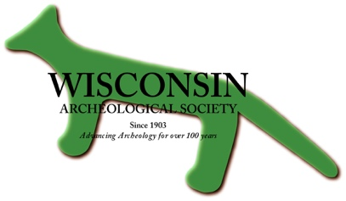
Wisconsin Archeological Society
2016 Fall Business Meeting
Saturday, October 29th 2016 Start Time: 10:00 AM – 11:30
Location: 312 Wimberly Hall, University of Wisconsin-La Crosse, La Crosse, Wisconsin (Directions at the end)
Board Officer Reports:
- Secretary Report
  - Discussion of Spring 2016 meeting minutes
  - Approval of Spring 2016 meeting minutes
  - Approval of Secretary report
- Treasury Report – Jake Rieb
  - Discussion of budget
  - Approval of Treasurer’s Report
Committee Reports:
- Editorial Committee – Kent Dickerson
- Education and Outreach Committee – Jaremy Cobble
- Elections Committee – John Broihahn
- Preservation of Site Committee – Rob Nurre
- Awards Committee – Heather Walder
- Multi-Media Committee – Jake Rieb
- Programs and publicity Committee – Robert Ahlrichs
Chapter Presidents Reports:
- Charles E. Brown
- Three Rivers
- UW-La Crosse
- Ritzenthaler
- Kenosha
- Rock River
Society Elections
- Announcement of Slate of Candidates
- Any Nominations from the Floor
- Vote upon candidates
Old Business
- Updating the Society By-Laws
  - Relationship between Chapters and Society
- Wisconsin Archaeology Handbook
- Devil’s Lake Centennial Commemoration
- Society table at 2016 MAC in Iowa City
- Inclusion of Increase Lapham Award in the Wisconsin Archeologist
New Business
- Making Archaeology Public Project
- New Baraboo Chapter
- New Society Emblem for
- Board meeting in November
- Spring meeting – date and place
Adjournment
Poster Session – 11 am to 1 pm
- Lunch will be provided, but we ask for a $5 donation to help offset the cost.
Directions to 312 Wimbly Hall, UW-La Crosse Campus
For GPS use the address: 1624 Farwell Street, La Crosse, WI. Parking is free on weekends in the parking ramp across the street from Wimberly Hall.

campus map http://www.uwlax.edu/map/index.htm (see below, the parking structure is #30 and Wimbly Hall is #40)
